Lync Client Manual Setup
Contents
Installing the Lync client on Windows 7 32-bit & 64-bit 2
Installing the Lync client on Windows XP 3
Installing the Lync client on Windows Vista 32 bit 4
Installing the Lync client on Windows Vista 64 5
Lync Client Installation Wizard 6
Configuring the Lync Client 8
Known Issues with First Login 8

This package includes Microsoft Lync (an upgrade to Communicator) as well as other updates necessary for the email transition the weekend of June 22. This package needs to be installed on all Abt project machines before June 25. Anyone who does not have the package installed by June 25 will need to use OWA (webmail) until the package is installed on his/her machine.

The purpose of this document is to walk the Technician through the installation of the Lync package using Windows 7, Windows Vista, and Windows XP. Please note that depending on the Operating System the first three steps are different, after completing the initial steps the technicians should be able to refer to the Lync Client Installation Wizard steps to complete the package install.

Installing the Lync client on Windows 7 32-bit & 64-bit

- Double click on the Lync package executable “AbtO365Install.exe” to start the Setup Wizard.
*If you get an error message at this point, try right-clicking and select “Run as Administrator”.
- Click “Yes” to continue
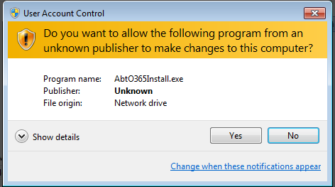

- Enter the administrator password when prompted
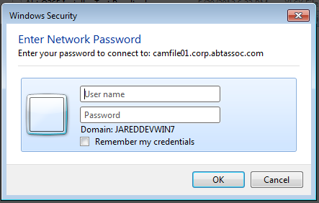

- Go to Lync Client Installation Wizard

Installing the Lync client on Windows XP

- Right-Click on Lync package executable “AbtO365Install.exe” and select “Run As” 
- Run as Administrator to start the Setup Wizard
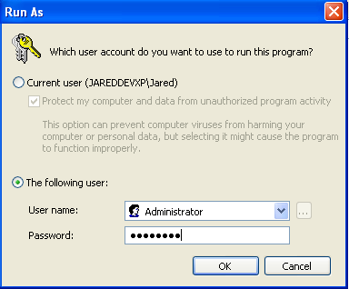

- Go to Lync Client Installation Wizard

Installing the Lync client on Windows Vista 32 bit

- Double click on the Lync package executable “AbtO365Install.exe” to start the Setup Wizard.
- Click “Allow” at the User Account Control window

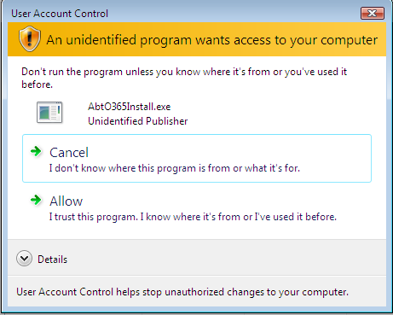

- Go to Lync Client Installation Wizard

Installing the Lync client on Windows Vista 64

- Double click on the Lync package executable “AbtO365Install.exe” to start the Setup Wizard.
- Enter the Administrator password when prompted at the User Account Control window
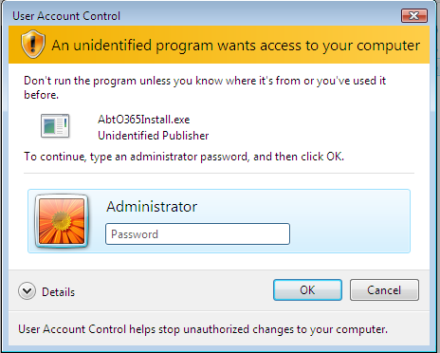

- Go to Lync Client Installation Wizard

Lync Client Installation Wizard

- Click “Next”
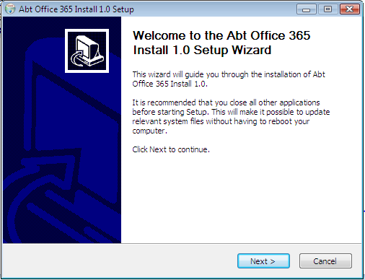

- Click “Install” to proceed with the installation
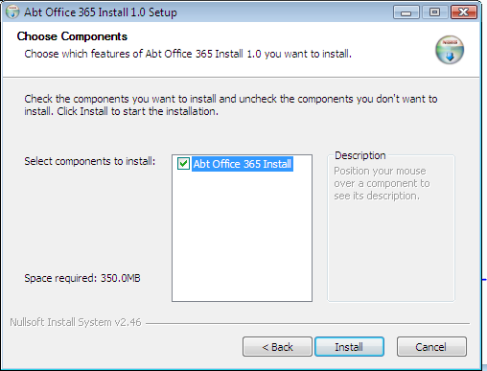

- Please wait while the installation is completed. 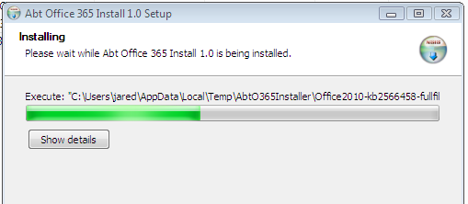

- Reboot when prompted
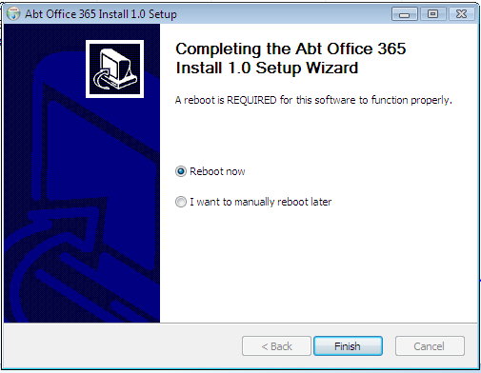

Configuring the Lync Client
- After the reboot the Lync client should automatically load.
Login using your full email address (firstname_lastname@abtassoc.com) and Outlook password.
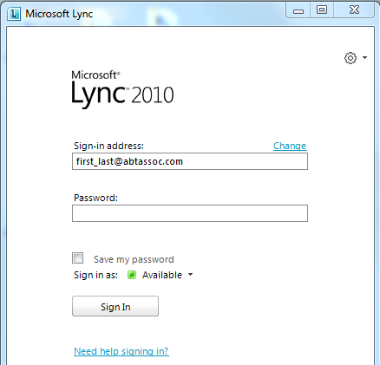

- After completing the Installation Wizard steps, you’ll see the Microsoft Online Services window with the Lync icon where the Office Communicator icon used to be:

Was This:  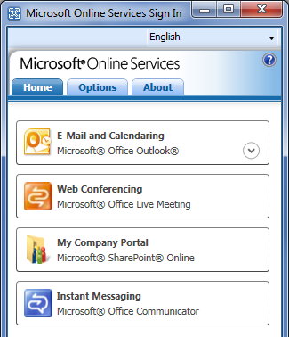 | Now This:  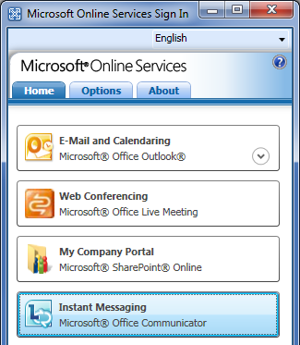

Known Issues with First Login

- After entering the password and clicking “Sign In” a “Cannot Sign in to Lync” error message pops up.
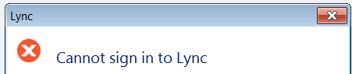
- You click “close” and the Lync window now has the “Username” field. Leave the “Sign-in address” field as is and put the project email address into the “username” field.
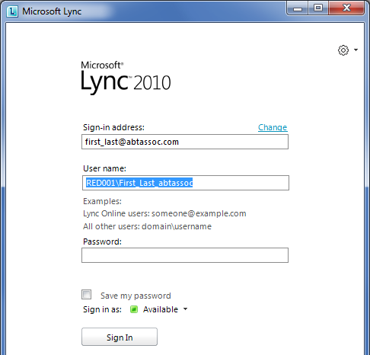

  - The Lync window opens, but there is no password field. When you click “Sign In” an error window pops up.
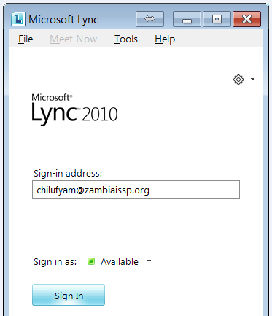
  - You will need to make a registry change. Open the Registry Editor (in Win7 type “regedit” into the search bar).
  - Go to Edit -> Find and search for “pool1.oco”
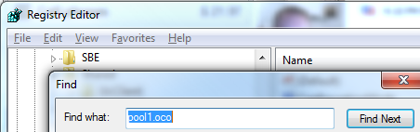
  - Double-click on the “ServerSipUri” entry.
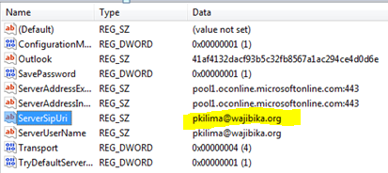
  - Set the value of “ServerSipUri” to FirstName_LastName@abtassoc.com (ex. John_Smith@abtassoc.com). Make sure that “ServerUserName” is set to the project email address (ex .jsmith@project.com)
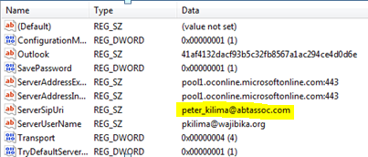
  - Exit out of Lync (from the task bar) and then open it again from MOSS.
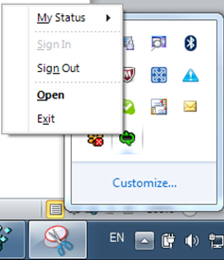
  - This time it should prompt you for the password. Enter the password (leave the other two fields as is) and click “Sign In”.

We will be posting other Issues/Resolutions here: http://abtassociates.smartertrack.com/KB/c49/lync-install.aspx
Please check this site for information before sending an email to the IT Service Center.

